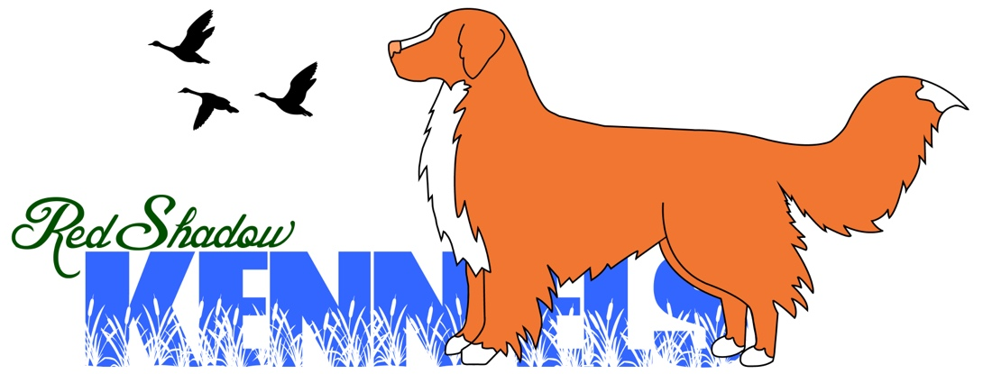
Breeders of Multiple Award Winning Nova Scotia Duck Tolling Retrievers

Information Outline
About Red Shadow Kennels:

Red Shadow Kennels was formed after we got our first Toller “Phoenix”. We learned early on with this breed that, while all Toller is special, our foundation bitch, Phoenix, was an unusually intelligent and “typey” representative of this breed. After 18 years in the breed, we have still never met or know a Toller with the drive, intelligence & Performance Phoenix has. We feel blessed to have started with such greatness! We know that the level of drive she had was so strong it has been carried down each generation from the beginning.
It is our mission to carry on Phoenix’s Legacy & Everyone who has ever followed us, supported us or has been able to join our Red Shadow Family/ Community has made this dream come true. She truly was our Phoenix & we feel is living on into each generation.

“Phoenix”
Marshland’s Rise of a Phoenix RE CD JH DJ TA
“Our Once in a Lifetime Dog”
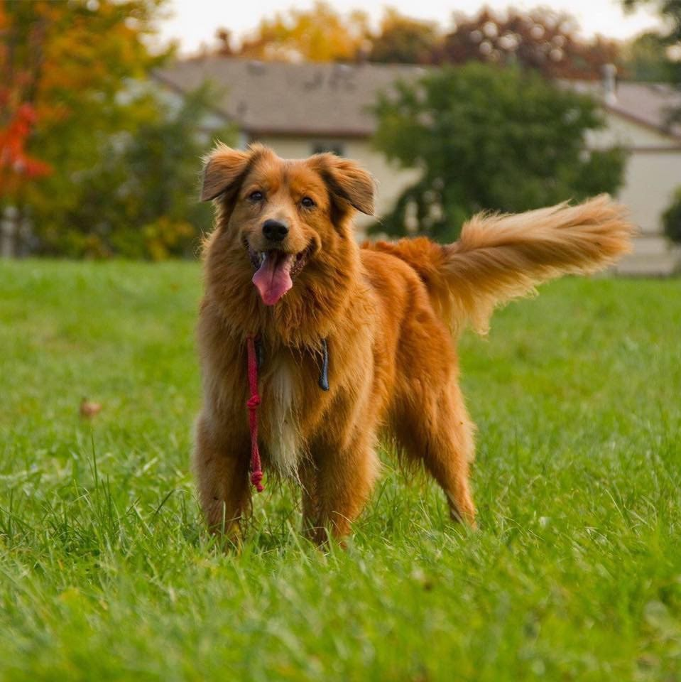
Our Mission:
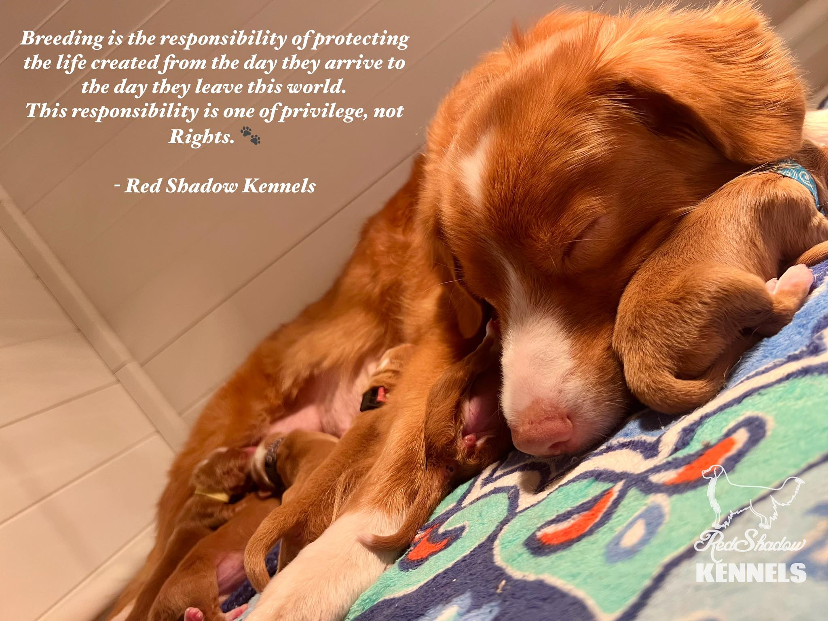
Red Shadow Kennels is very fortunate to own and have access to some of the most award winning Tollers in Both Canadian & American History. We pride ourselves on producing the best puppies for both Confirmation and Performance out of the Top Lines in North America. We work very hard to prove all our dogs in the Show Ring and a variety of Performance disciplines in order to produce only the best representations of this amazing breed.
This allows all of our dogs to meet the breed standard for structure, meet the breed Performance for things such as Hunting, Agility, Obedience, Rally, & Dock Diving, as well as produce healthy puppies that can go into amazing homes and succeed! Red Shadow Kennels also ensures that every single Genetic Test or Health Clearance is done on the Males and Females before they are ever bred.
Red Shadow Kennels is very focused on putting absolutely everything we can into each and every puppy. We strongly believe that being a responsible kennel/breeder is a privilege, not a right and should only be done at the highest of standards. We work hard to find families that can be a part of our family and who will allow us to be a source of information, a support to them and a connection for the life of our dogs. We look for families who will learn from us and who not only want the best for their dogs, but who will love these amazing animals as much as we do!
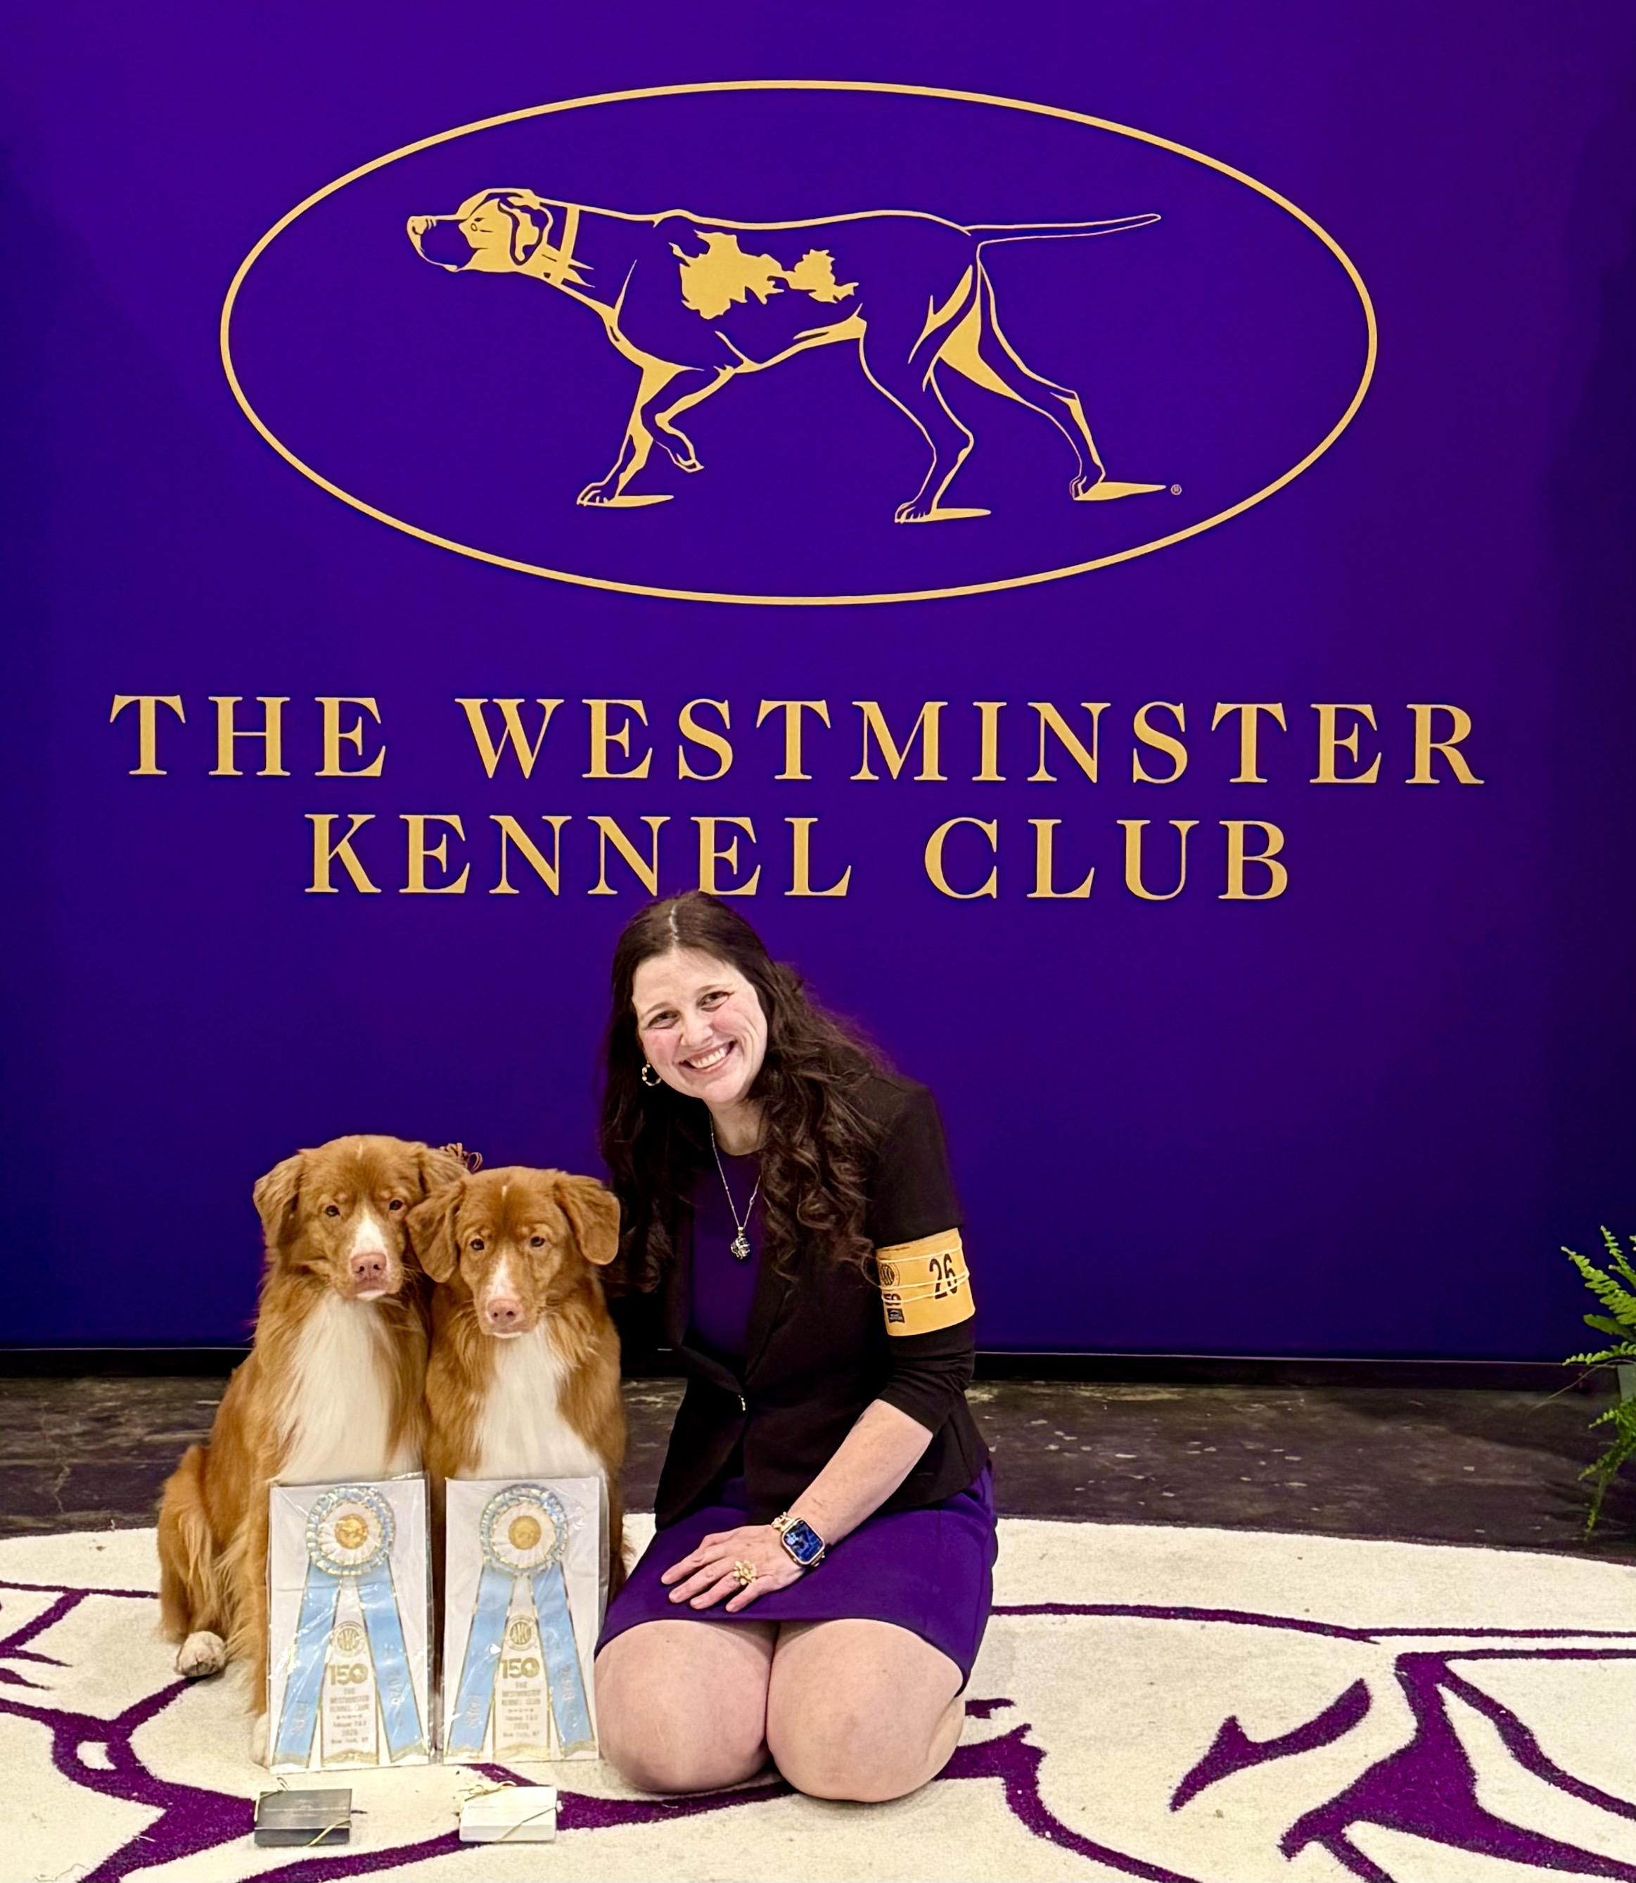
About Us:

Shauna Canjar Dainton is the owner of Red Shadow Registered Nova Scotia Duck Tolling Retrievers.
Shauna is a Registered Veterinary Technician (Honors, Seneca College), a Certified Veterinary Assistant (Durham College) and Certified Performance Horse Handler (Honors, University of Guelph at Ridgetown) who has had the opportunity to further her career in Veterinary Clinics and Zoos all over the world. Shauna currently works as an Emergency Veterinary Nurse in an Emergency Clinic and specializes in Canine Whelping, Reproduction & Neonatal Care.
Shauna is also a Certified Obedience Trainer and a member of the Oshawa Obedience Club. She also promotes Raw Food Diets, Limited Vaccine protocols, & Alternative Veterinary Care (Holistic/ Homeopathic).

Shauna’s biggest passion for her kennel is accomplishing/ Bettering the breed by proving her dogs in both Confirmation & Performance Sports. Red Shadow Kennels is proud to have over 45 recognized CKC/ AKC titles across our Tollers, with many more to come.
It is Shauna’s Mission to both accomplish and better this breed as per their standard.

The Standards we hold ourselves too:


Confirmation/ Performance Titles: All of our dogs must have at least one Confirmation Title (Championship “CH”) and at least one Performance Title before being part of our breeding program. We usually get between 4-6 titles on each of our dogs before breeding as we work hard to prove each of them in order to always be bettering this amazing breed! We strongly believe that both of these are equally important, as Conformation proves our dogs are structurally sound, heathy and most of all a great representation of this breed. Performance is also key as these titles are done to prove our dog’s trainability and that they can perform/work to the breeds standard in various disciplines (Hunt Trails/ Field Training, Rally obedience, Obedience, Agility, Dock Diving, Trick Training, Barn hunt, Scent Work). Red Shadow Kennels is Proud to announce we have earned over 25 titles across are Kennel and we have many more to come.

Health Clearances: All of our dogs (& any dogs we use from other kennels) have completed all Breed Genetic & Non- Genetic Health Clearances before entering our program.

- Breed Specific Genetic Tests: Can be done at any age in our dogs & is completed UC Davis Laboratories, Pawprint Genetics (Orivet) & the OFA. The current Genetic Tests available to our breed that we require are:
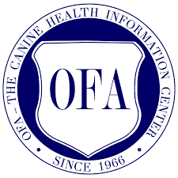
Juvenile Addisons (JADD) | Cleft Palate & Syndactyly (CLPS)
Progressive Retinal Atrophy (PRA) | Dilute (BUFF/ DTR Locus)
Collie Eye Anomaly (CEA) | Chondrodystrophy (CDDY)
Degenerative Mylopathy (DM) | Cardiac Laminopathy (CLAM)
Degenerative Encephalopathy (DE) | Cerebellar Degeneration Myositis Complex (CDMC)
Cleft Palate (CP1) | Cleft Palate & Syndactyly (CLPS)

- Hip/ Elbow Clearances (Non-Genetic): Are not done till the age of Two when all growth plates are closed & Clearances is considered official. XRAYS are Completed by our Repro Specialist vet & Evaluated through the OFA Specialist program or through the PennHIP Measurement Calculation Clearance.
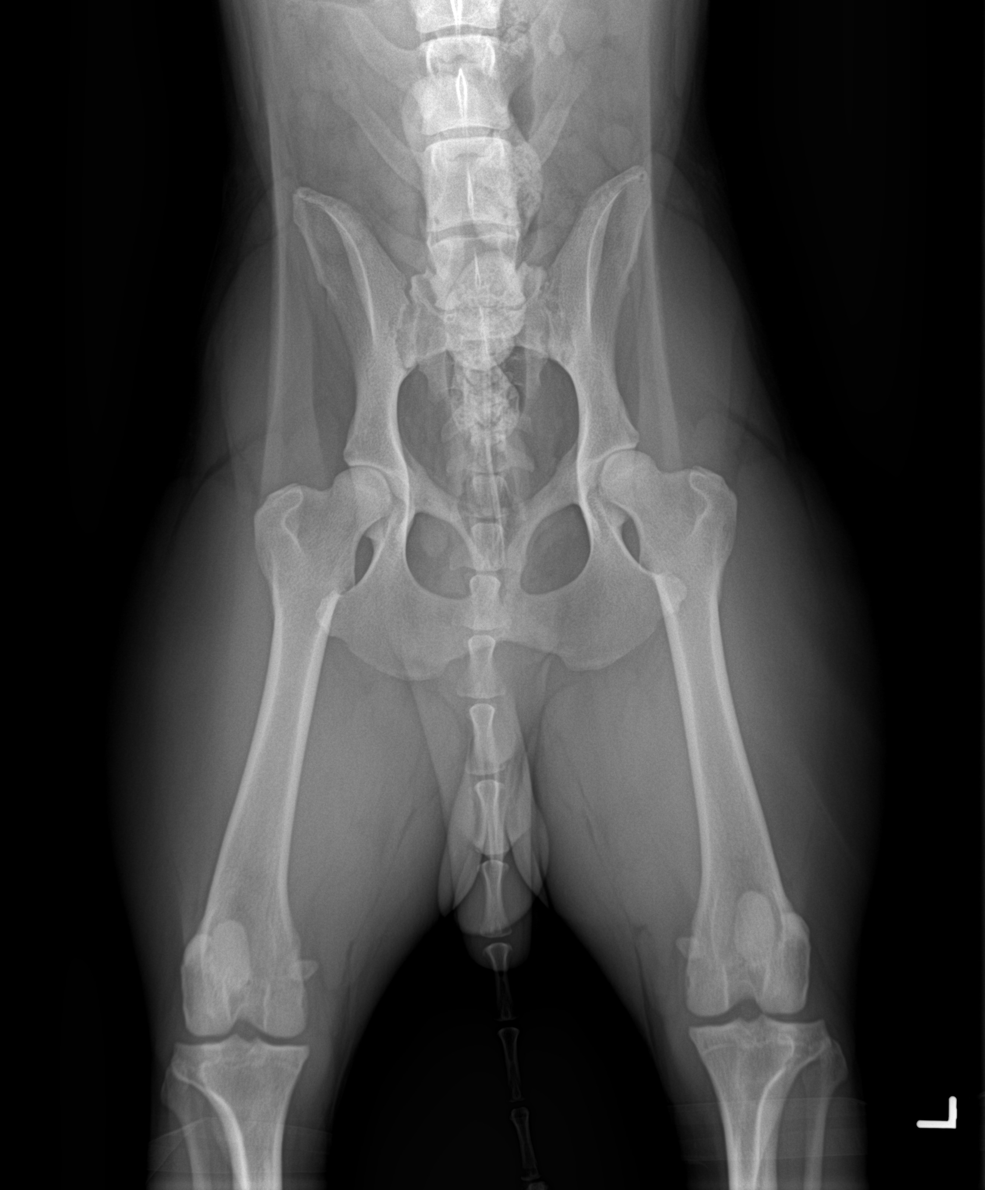

Puppy Count Radiographs: X-rays are done on our females around day 55 of pregnancy when the bones of the pups are calcified/ visible in order to confirm health, size, structure, position & most of all, how many puppies are expecting. This helps us have a safer whelping and chance of all our puppies being born healthy.

Our Puppies:

All Red Shadow puppies are raised indoors, in a family setting. They will have exposure to other dogs, cats, and children.
From the moment of birth, the puppies are constantly being evaluated for structure, temperament and personality. They are frequently checked, desensitized, played with and handled to see how they are developing. We start Crate training, Collar training and leash training, with weekly nail trims!
If the weather permits, we will take the puppies outside and let them play in the grass or snow!
Around 7 weeks of age, we seek the opinions of other experts in canine behavior and structure in order to validate the traits we see emerging. This is one of the many important steps we take to match our puppies with their families. We assess our puppies for Hunting, Confirmation, Obedience, Agility and overall great active family companions.

Each Red Shadow puppy will be examined by our licensed Veterinarian around week 9. During this visit, they will receive their first vaccinations (Parvo/ Distemper), and get a full health exam.
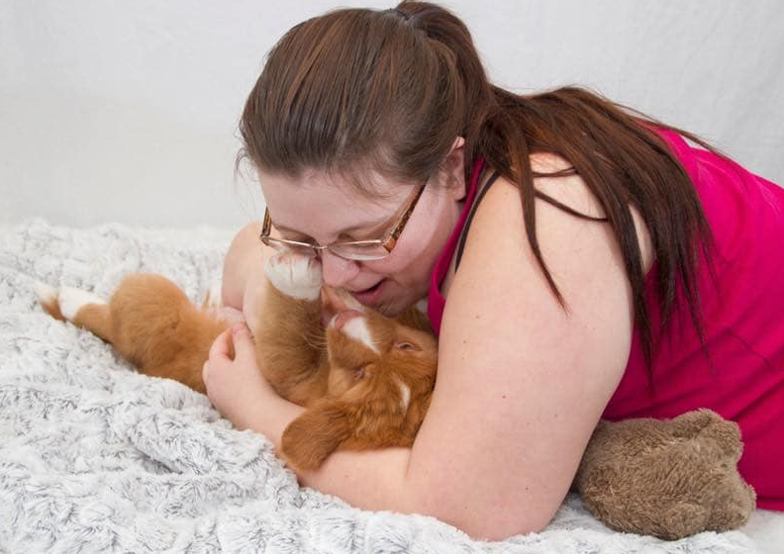
Microchipping & Deworming is done by us between 4-9 weeks of age.
Our Puppy Training Program:
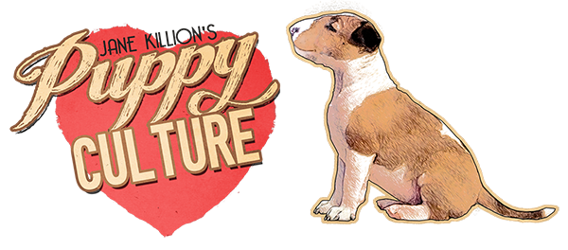
Red Shadow is a strong advocator of the "Puppy Culture" 12 week program and strongly encourages its puppy owners/ those interested in our Kennel to learn about this amazing program we follow. http://www.puppyculture.com/.
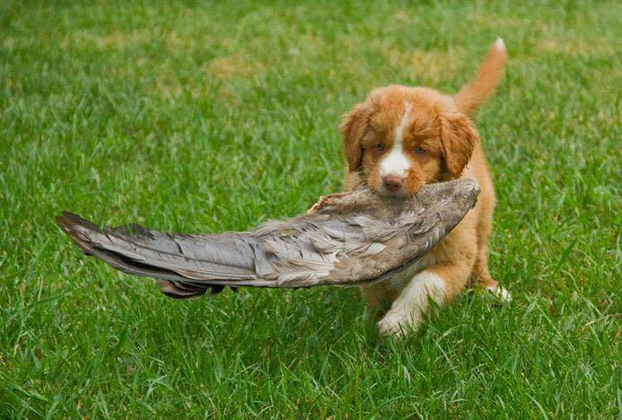
We are proud to have been the 2nd Kennel of this breed in Canada to use this program. Puppy Culture is the gold standard in puppy raising/ enrichment. This program, teared both breeders and owners critical fear periods in the first 10 weeks, Early Neuro Stimulation & much more!
How we Match our puppies:
In order to match you and your family to the right puppy, all potential puppy buyers are required to fill out the “Red Shadow Puppy Buyer’s Questionnaire”.
It will allow us, as the breeder, to learn about you, your family!

We match our puppies with their homes using a variety of testing in Behavior, Confirmation & Performance. All of this testing is done in the first 9 weeks of age. It’s for this reason we are not able to tell families if we have a certain puppy or gender available when younger. We do our best to match if families have a gender preference, however we can never guarantee this, as we personality is our priority for matching. jj

It’s extremely important that we place our puppies based on their performance level and temperament so that we know they have exactly when they need. But also, so that our families have a puppy that can do all the wonderful things they are interested in.
Once you have filled out the Questionnaire, should we feel we have a puppy available that meet your interests or we feel you’re a good match for our kennel. Should we decide to move forward with a family, we will schedule a Phone Interview to continue the process.
Stipulations/ Restrictions:
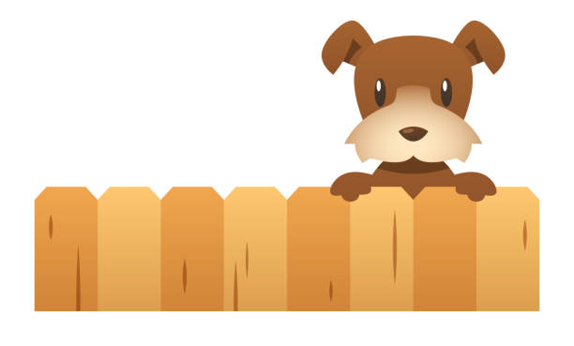
- Fenced Yard: Red Shadow Kennels will NOT accept any applications for families without a Secure/Locked Fenced Yard that can be locked. We are open to working with families who intend to put one up, but will not be accepting Invisible Fences, Dog Parks, Kennels or Runs as replacements.
Apartments/ Condos: A fenced area must be attached directly to the building of residence, to meet this requirement.
We love each of our dogs more than anything and due to terrible loss and negative previous experiences, this stipulation has been put in place.

- North America Restriction: At this time, we ONLY can consider families within North America. We never ship puppies and simply feel the requirements such as age, and vaccines for puppies to go into other countries is not what we are looking for as a kennel. We provide everything needed to our US families that are approved to take their puppy across the border.

- Children in the Home: Red Shadow Kennels Required as minimum of 2 year age gap between a puppy and children in the home. We understand a lot of families that apply to use are planning on starting a family in the coming years or perhaps already have children. Like many breeders, its important to us that the puppy has the one on one time, especially in the first 2 years. Puppies need to grow, meet their mile stones, have the one on one training & most of all, have the best foundation and routine before families bring home a new baby. Its for this reason we ask that families consider their timeline between bringing a puppy home and welcoming a new baby. We ask that their be a minimum of 2 years between them. For families that already have children, we recommend at least a 4 year age gap.
We understand for some, this stipulation can be a bit of a surprise. Tollers are great dogs with children, however they are a very high energy breed, that need a lot of work and is prone to stress/misbehaving when their are a lot of changes in the home. We as breeders, especially see concerns around 6-18 months of age, when our dogs are not getting the exercise, mental stimulation and attention they need at such a important age. We respect that children are even more work and need to meet their own milestones. For these reasons we hope families can understand that a Toller is just like a child and needs to have its own time and space with the family especially the first 2 years.

- Other Dogs in the Home: Any dogs already in the family, MUST be 2 years or older by the time a puppy comes home. Its very important for families applying to understand that when looking at getting a new puppy, that the relationship with your current dog needs to be a Teacher/Student Relationship and not a Student/Student one. The success of both dogs in their family and the development in the relationship is very important when there is this age gap. It allows the older dog to teach the younger one life skills/boundaries because they are mature and have the experience already. This also allows families to have the one on one time with each dog so that the training is in place before a new puppy comes in, and prevents the two dogs from bonding too closely with one another. There is a lot of research showing that the age gap is very important for the developmental and success of all the dogs in the family. It’s also for this reason we do NOT allow families to apply for sibling/ 2 puppies at one time from a litter.


- Shipping Puppies: Red Shadow Kennels DOES NOT ship or fly puppies out in cargo: All our owners, no matter the distance have driven to come get their puppies and attend our complete seminars regarding Diet, Training, Behavior, Grooming, Vaccines and so much more. By studying puppy culture, dog behavior and key fear periods through a dogs life (Using Puppy Culture), it’s easy to see how flying a puppy alone in cargo, can be detrimental to their health and long term. If approved this is something we can work with you on as we do with many of our families that are far away. We do make exceptions in the case were the family flying home after picking up the puppy has the puppy at their feet in the cabin, as a carry-on. This is a very different and safe experience for the puppy.

- Dogs are NOT Gifts/ Surprises: Due to obvious reasons, we need all members of the family & in the household to be actively involved in our application process and if we proceed to an interview. We don’t allow families to apply who are wanting to surprise or gift puppies to other family members. This is not something we are comfortable with. Many people in the dog world know that the reason shelters often fill with dogs and cats after Christmas is due to them being gifted and then abandoned.
7.) NEW USA/CANADA BORDER RESTRICTION:
It’s been Almost a years since the CDC/ American Border put new Restrictions in place that prevented a lot of Canadian Dogs from going to the US because they wanted them to be at least 6 months. While a lot of organizations have tried to get this changed & made some success, the 6 month rule has still been in place with no signs of any changes happening at this time.
Red Shadow Kennels has always been so close with our American Families. About 30-40% of all our amazing pups live in the states so the stress of this horrible decision on the part of the CDC has been Devastating & stressful.
June 2025 Update: We are at a point of trying to find a solution/ option for the right families in the US about this. We are at a point of ACCEPTING American Families again who meet the following requirements:
- Go through our full application process like normal and meet the point of approval
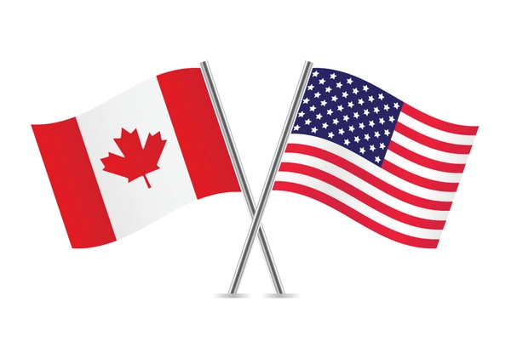
- Are willing to come for a visit to our kennel & attend our classes Before their puppy goes home at 6 month and to be involved in our process
- Is open to a Boarding fee to help us cover expenses for their pup to stay for 6 months while stilling be involved long distance as much as possible
- Meet other requirement we may request during approval (Border requirements, Deposit/ Boarding fee etc…)
These are some of the requirements we would need from US Families applying. We would want families to understand the commitment we would be taking on to do this & that we want the right families to feel involved during this. Puppies who would be with us for the 6 months would be full crate trained, potty trained & have basic obedience but families would still be required to help the puppy transition to their new home by still working on a good foundation for their puppy. Especially through Physical & Mental Stimulation.
This will ONLY be offered to the right families who are serious families about going through our process & who have the same level of commitment we are putting in by taking this on in order to allow American families to still apply.

What Makes Red Shadow Kennels Different from other Kennels?

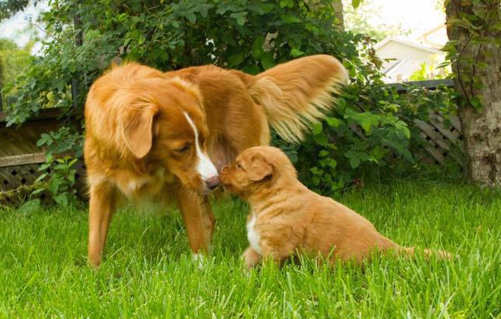
Here at Red Shadow Kennels we have always been one to set ourselves apart by doing a lot more with our puppies. At the end of each day it is all about our dogs, they are the reason we do everything we do and we strive to put a lot more work and time into both our owners and their puppies every day for the life of our dogs.

What is included with a Red Shadow Puppy?

- The complete 12-week Puppy Culture Program: Is done with each puppy from the moment they are born. This program is the gold standard for puppy enrichment, early neurological stimulation, socialization, training, understanding canine fear periods and most of all it is the leading program in raising puppies to be brave, resilient to fear and most of all ones that can take on the world with their families.
  - This program has some of the top breeders around the world supporting/utilizing it and we are proud to be one of the very first Nova Scotia Duck Tolling Retriever Kennels to use this program
  - 10 Week Rule – We keep our puppies will 10 week of age. This is so important as Puppy Culture teaches us that the biggest fear period in a dog’s life is between weeks 7-9. For this reason, puppies that are sent home at 8 weeks are more likely to have a negative fear reaction that will affect them for the rest of their life. Puppies kept till 10 weeks are healthier, less stressed and less likely to have a detrimental fear reaction as they are kept in the normal environment they know until their fear period is over.
  - We have lots of testimonials/references from our owners and people around the world who have puppies raised with this program. The results are truly amazing and are a lifelong benefit for the puppies.
  - https://www.puppyculture.com/what-is-puppy-culture.html

- The Complete Puppy Culture Video (4+ hours): We set ourselves apart as we not only use the program every step of the way with each of our puppies but we also work hard to have our owners involved in what we do. It’s important to us that they see just how amazing this program is and that by using the program like we do that it will benefit and affect our dog’s behaviour every day for the rest of their lives. The complete program is available for our approved owners through the private login on our website.

- Private Owners Library: All our owners will have exclusive access to our private login section of our website. Where they can access all our Published articles/white paper we have written, private training video, feedback area and all the resources we offer. We have published over 15 articles so far and always have more to come!

- Microchip/Vaccines: All puppies are microchipped and part of a “Limited Vaccine Protocol”, specifically designed for the safety of this breed.

- Personality/Confirmation Testing: One of the most important things a breeder can do is choose which puppy is perfect for which family and which family is perfect for that puppy. It is equally as important to us that we match a puppy with a family based on what that family is looking for, (Ex: Active companion, Hunting dog, Show dog, Performance dog etc..). But what often gets missed is also how important it is for a puppy to have a home that meets their needs and is one where they have every advantage in life. This is why we do a series of Confirmation and Personality testing on our puppies with some of the top Toller Experts in Canada in order to make sure we choose the perfect puppy for the perfect home.

- Seminars/Classes: We are one of the only kennels in the world that team complete seminars to each of our amazing puppy families! Included in our puppy package is information on: Canine Nutrition, Grooming, Veterinary Care, Vaccine Protocols, Training, Sports/Events, Precautions, Developmental stages and so much more. Our Seminars included are approx. 10-12 hours and it are designed to go over everything possible with our owners to give them support and get them ready to bring home their new baby. We meet with each family individually so they get the one on one support and time with us, with complimentary lunch.
**These seminars are mandatory for all families. We usually expect our owners to stay with us at the kennel for a minimum of 1.5 days to complete the classes**
We are very flexible, so if a family is approved we are happy to book seminar days to work around the family’s schedule! We also have a number of great hotels nearby we can recommend for families living farther away!

- Life Long Support: We are committed to our dogs and their owners for their entire life. We are not going anywhere and will always provide answers, information, support, updates and guidance at any time during the life of our puppies. We strive to give ours dogs every advantage in life and be an ongoing support for our owners. Think of it like you have a Registered Veterinary Technician on call 24/7!!

- Published Articles: Red Shadow Kennels wants to make sure our puppy owners are always up to date on the latest things and have all the information they need to keep their dogs healthy, happy, and active. We publish new articles every 4-6 months and they are available to all our owners for life. We cover common questions/topics, health information, training etc…

- Private Facebook Group Access: We have a private group available to our approved owners on Facebook that allows access to important information and events. But most of all it is a place our owners can access to get helpful information and reach out to one another for support. It was created to be a place that feels much like a family, filled with people who love their dogs more than anything and want to do the best for them. A great support system for all owners. We are looking for families that have an interest in joining our “Red Shadow Family” & who want to be part of the community we have built.

- Large Take Home Puppy Package: Our puppy package has no limits! We include a full binder/manual with over 30 pages about training, grooming, nutrition, health care, safe vs. not safe toys/activities and so much more.

  - Coupons
  - Three Days of Raw Food for Pup to start on.
  - Toy/ baby blanket (That smell like the puppies mom/ family to help them with the transition to your home!)
  - Birth Certificate
  - Red Shadow’s “Limited Vaccine Protocol”
  - Pedigree
  - CKC Registration Paperwork
  - Red Shadow Kennel Contract
  - Microchip information
  - Important articles/ Presentations
  - And much more!!

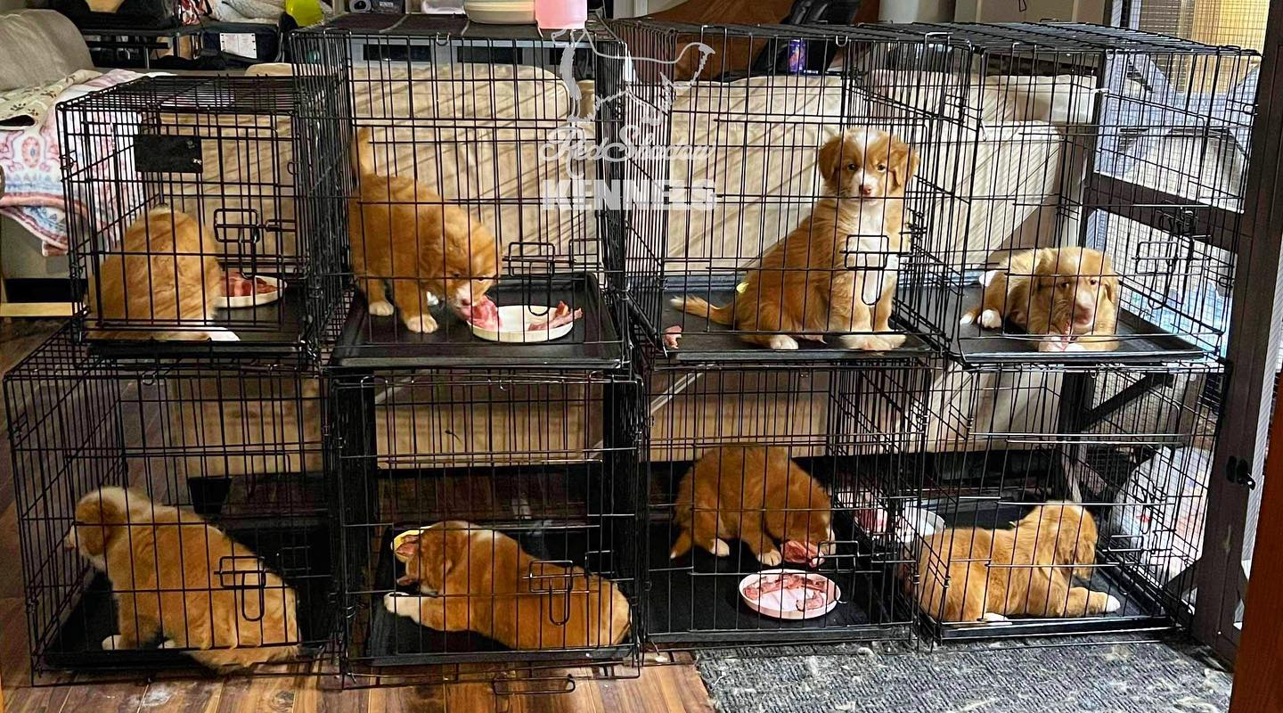
- Early Puppy Training: We believe in starting things early and making life at home as easy as possible for our puppies. This is why we start Crate Training, Leash/Collar Training, Potty Training, “Manding” and so much more with each of our puppies before they go home. This helps our owners with the training process but most of all reduces the stress/transition for our puppies when they leave.

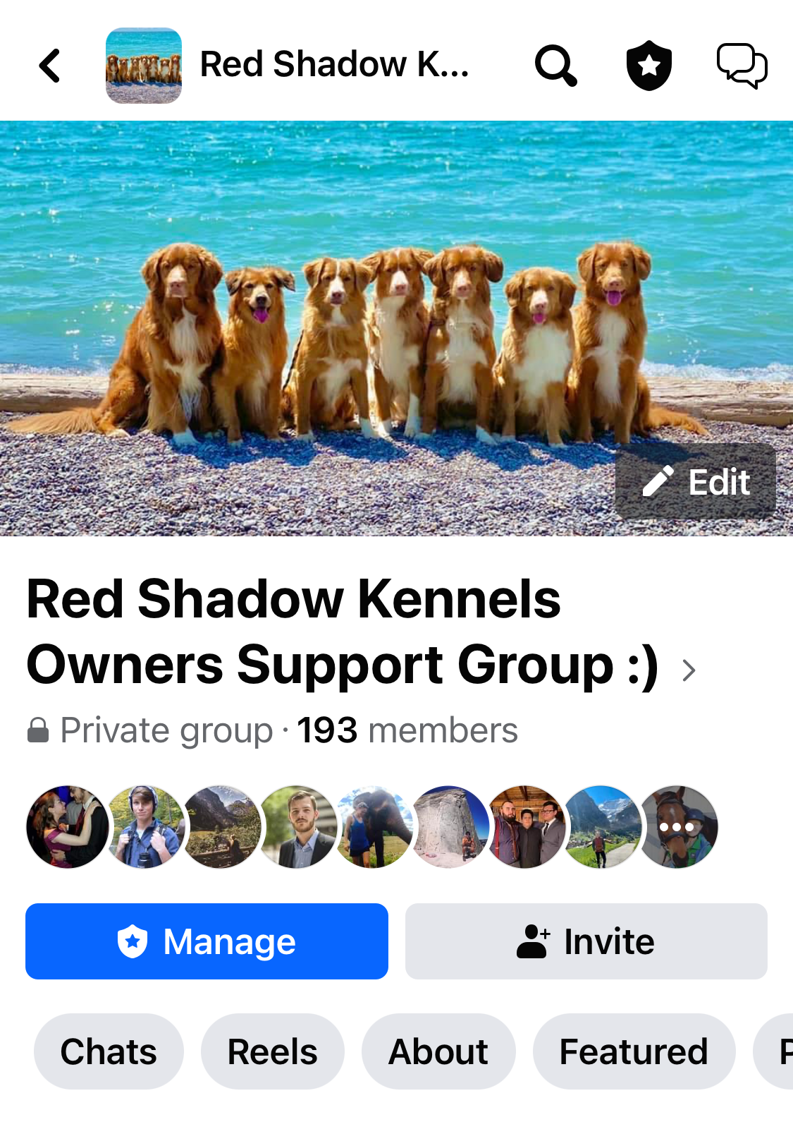
- VIP Boarding & Grooming for Our Red Shadow Tollers over their lifetime: We will always be avavliable to our families for Boarding & Grooming at any point in the dogs life. No matter the length of stay, our Tollers are family & are treated just like our pack when they come back to visit. We offer discounted rates for our families as well as LOTS of updates! They are our family!

- Kennel Classes/Events!: Every year we like to put on a number of classes, health seminars, events and fun days for our families. As well as set up as many reunions as we can for our Toller community! In the past we have been able to participate in events like the annual “Furry Friends 5K Walk”, which raises money for local rescues and supports our community! Each year we would have about 15-25 of our amazing dogs come out with their families (this number is only growing as we extend our family!) for the walk and a BBQ afterwards. We would love to provide more information to our approved owners about this great event!

Cost to Adopt a Red Shadow Puppy:
If a family is approved, the first step is a Non-Refundable Deposit, which will guarantee you a puppy from one of our litters. This deposit will then be applied to the total cost of the puppy. The Balance of the total is due on day the puppy goes home/ the contracts are signed.
Current Litter Cost:
- Deposit (20%): $1000 – Due after approval - Non-Refundable Deposit that covers resources & material costs you receive right away, as well as our seminars/ visits.
- Balance (80%): $4650.00 - Due on date of puppy pick up – 10 weeks of age
Total: $5000 + Tax = $5650.00

US families: For Families in the US who are able to apply (Are approved & are working with us on the 6-month Border rule). The cost is to be paid in USD Dollars. However, we do offer a discount due to the exchange & due to the additional boarding fee we ask for to keep our puppies for the 6 months in order to cross the border. Families in the US are welcome to apply, & we can talk about this more.

How do we choose our cost?

Breeders who meet the standards we do. Understand that there is a lot of costs associated to us being able to produce the very best of this breed, in health, structure, temperament, & lifelong care for our dogs & their families.

We want families to feel they had full transparency with us when going through out process & when paying for their puppy. We want you to feel confidence the adoption fee went toward the very best in breeding standards & practices with a goal to provide long term health & support for your puppy.
Here are some of our costs Red Shadow has:
- Breeder Education/ Certification in Canine Whelping & Reproduction: Initial Seminar & Books: $2500 (Workshop in the US), Yearly Educational Classes/ Updated Material: $400
- Pet First Aid Certification: $300
- Titles/ Showing (Confirmation & Performance) for each dog in our breeding program over the first 2-3 years: $4000-$5000
- Health Clearances per dog in our breeding program (Hip/Elbows, 9 genetic tests, & other tests that have to be repeated per breeding): $2000
- Xray for mom to confirm number of puppies before birth: $600-$800
- Possible Ultrasound: Confirms pregnancy, health of pups: $400
- Annual CKC Membership: in order to remain current as a registered CKC breeder & in good standings: $100
- CKC cost of Registering the litter: $80
- CKC cost of Registering each puppy individually with their new family $90 per puppy born
- Stud Fee: Most of the time breeders don’t own the one of the parents (Typically the Male) in order to add genetic diversity to the breeder. Stud fees can vary from the cost a puppy, a physical puppy back or both, this is based on the prestige of the male: $5000-$10,000 (Based on price of Puppies from litter)
- Possible Artificial Insemination Costs: Should this be the only option for the stud being used, all costs are covered by the owner of the female wanting to have the litter. They have to cover all costs for the medical at the repro clinic, plus a fee to the stud owner for what they have put out to get the collection. Storage. This applies if natural breeding was not an option: $2000 - $4000
- Cost of food and supplies from Birth to 10 weeks for puppies: $3000 (Breeder like us that us protocols like "Puppy Culture" are keeping their puppies 2-3 weeks longer than breeders with lower standards).
- Medical costs per litter (First vaccine, exam, deworming, microchips): $1600 per litter
- Medical Neonate Set Up:
  - One time purchased Items: $7000 (Incubator, Oxygen Concentrator, IV Fluid Pump, Surgical Tools, Heat lamps, Weight scale, Medical Bedding/ Vet Bedding, Whelping box + Extensions, Pig Rails, Warming Pen etc…)
  - Items Required to order every litter: $1500 (Needles, Syringes, IV fluids/ lines, Suction Equipment, Bandage material, Medications, emergency supplies etc..)
- Resources/ subscription fees (Puppy Culture) for services we provide out families: $80 per puppy/ family
- Puppy packages (binder, gift certificate, food and toys we provide): $60 per puppy
- Seminars (this is not something most breeders do, however we are big on education and support. All our owners have to attend 5 seminars with us before taking their puppy home. This is a 1.5 day commitment and is something we include in our cost of the puppy): $250/ person
- Staff Training/ Help: We have a select few people who help us with our 24 hour night watch of the puppies the first 2-3 weeks, & with the weekly care, tasks & schedule we follow till 10 weeks. They help us with Microchipping, meal prep/ puppy packages we send home, our classes we do with the families, the day to day tasks, photoshoots, Puppy evaluation days, grooming, enrichment, deworming, feeding & so much more: $500/ week we have pups.
- Other costs not covered: $3000-$5000
Not all breeders have the same standards as us, nor do they have the same costs, based on how they choose to cut corners. These costs will never cover or factor in our time because we have always considered this to be a 24/7 labor of love that does not generate a profit for us.
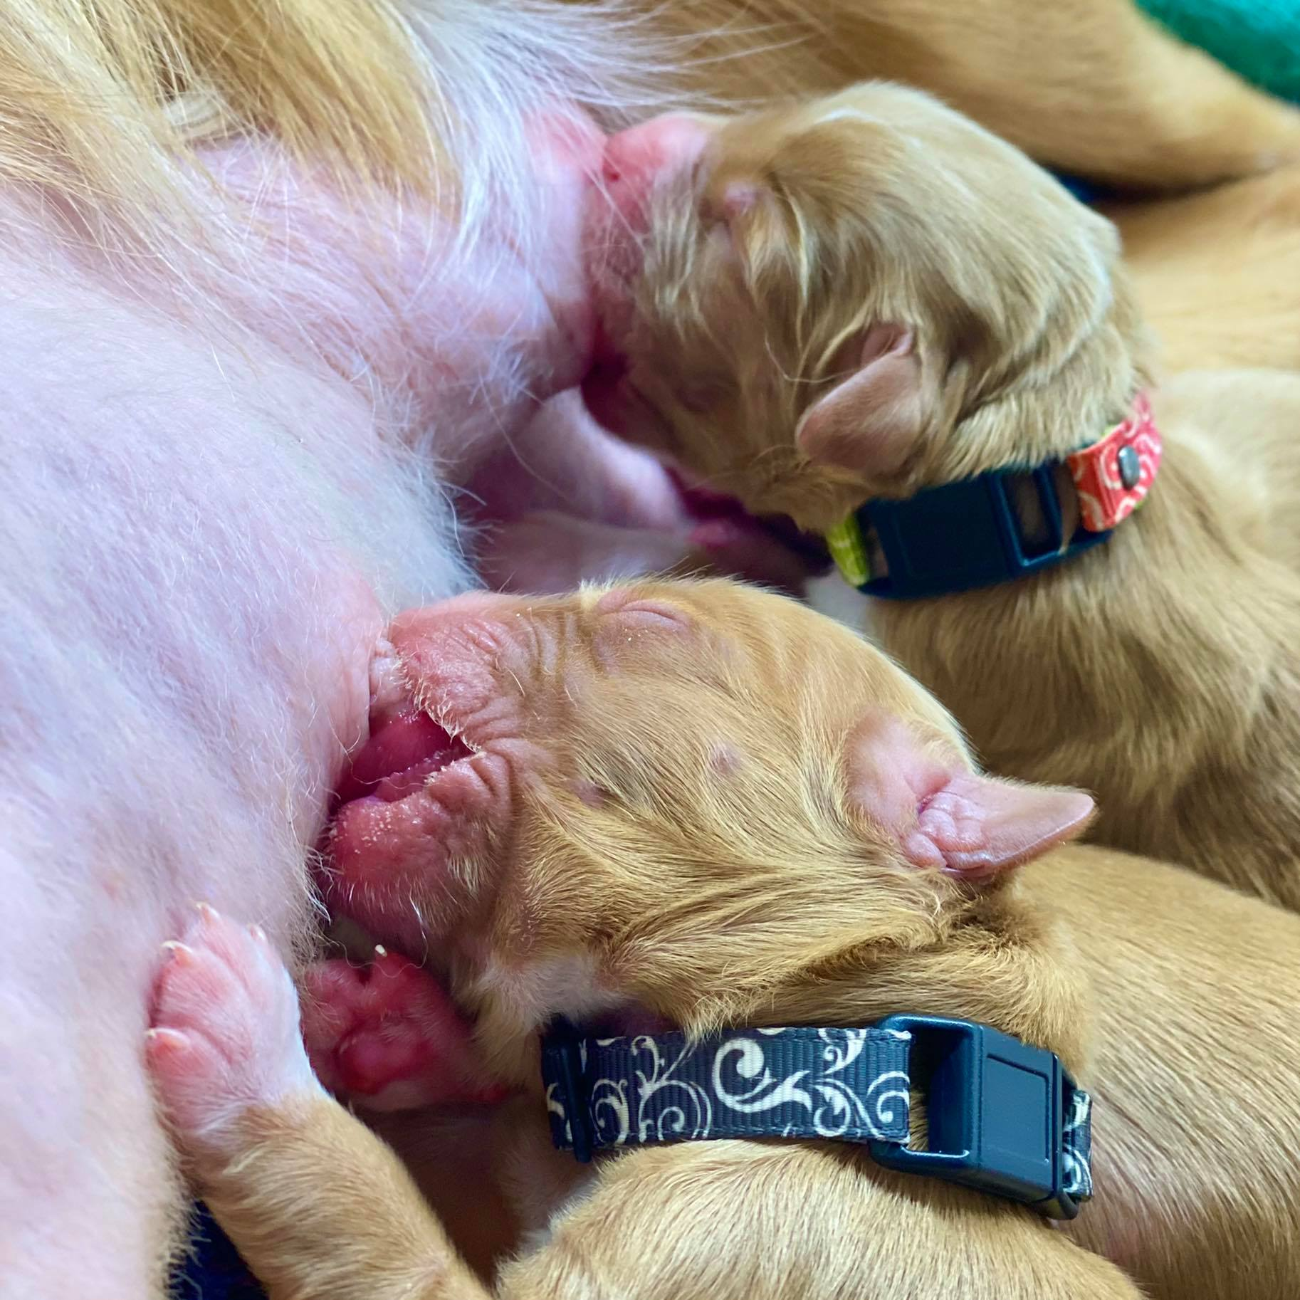
We work very hard with each litter to improve, learn and provide more for our puppies, owners and dogs as we learn and get bigger. Due to this and the growing economy we do have to adjust our prices accordingly with each litter in order to balance our cost. This price adjustment allows us to continue doing all the best Performance and Confirmation Titles, New Health Clearances for the breed, puppy enrichment & much more!
Every dollar we receive for our litters, goes 100% back into our program. To allow for our success, our growth & for us to do better by this breed.

Thank you for your time:
We hope you can see the Red Shadow Kennels difference we make and the love, time and effort that goes into each one of our puppies for life. We hold ourselves at the highest standard as breeders and each year work to keep improving in order to be better for our dogs, puppies and amazing owners who join our extended family!

Our commitment to you and your dog is a lifetime commitment. If, at any point, you need support, direction or guidance on raising one of these special dogs, we will always be here to help!

Sincerely,
Shauna Canjar Dainton RVT
Red Shadow Kennels – Nova Scotia Duck Tolling Retrievers
Hamption, ON, Canada
(905) 925–6278
www.redshadowkennels.com
Like us on
Facebook: https://www.facebook.com/RedShadowTollers?ref=br_tf
Follow Us on Instagram: https://instagram.com/redshadowkennels/

